# NEURAL NETWORKS: REPRESENTATION

## Motivations

*Non-Linear Hypotheses*

* Complexity of non-linear classification
* O(n^degree) ~ (n^2)/2

*Neurons and the Brain*

* Neuro-rewiring experiments

## Neural Networks

*Model Representation I*

* Neurotransmission
* Neuron model: logistic unit
* x0: bias unit
* Activation function
* Parameters = weights controlling function mapping from layer j to j+1
* Neural network
* Layers: input, hidden, output
$a_{unit}^{layer}$

* $Θ$ dimension: sj + 1 x (sj + 1)

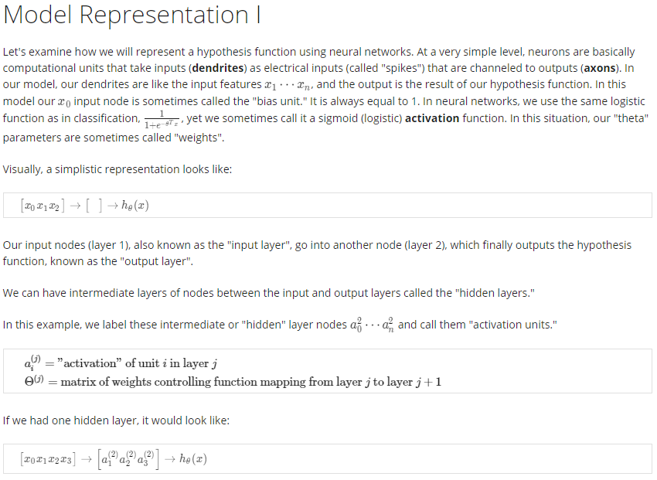

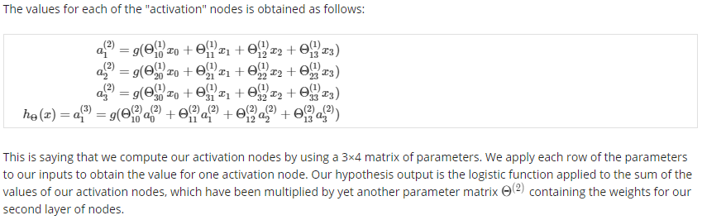

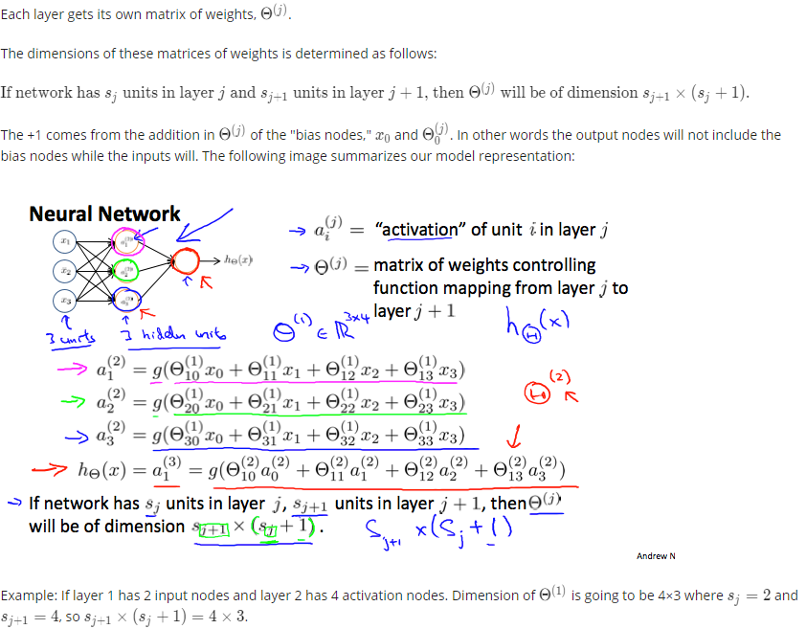

*Model Representation II*

* Forward propagation: vector implementation
* z(2) = =
* Network architecture

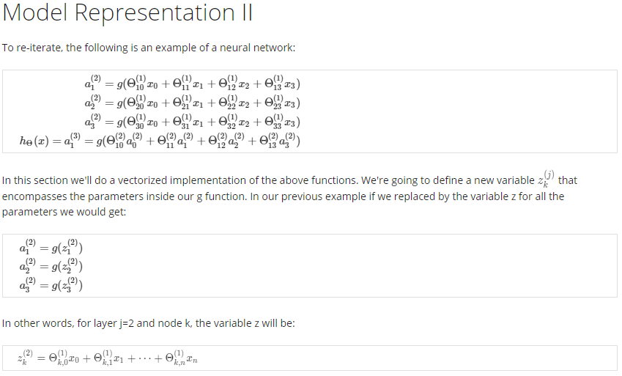

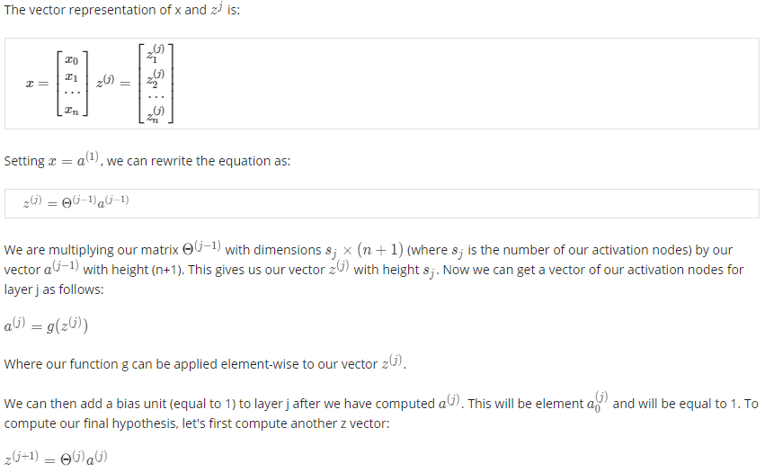

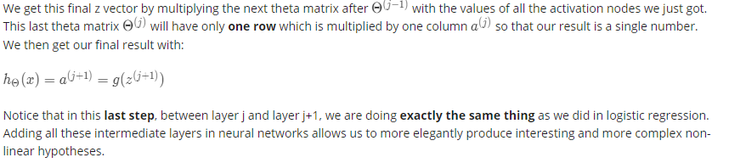

## Applications

*Examples and Intuitions I*

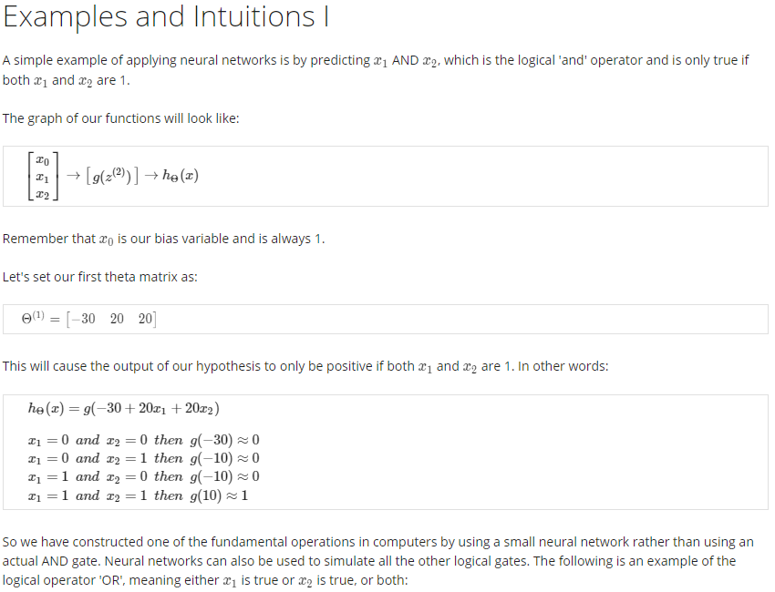

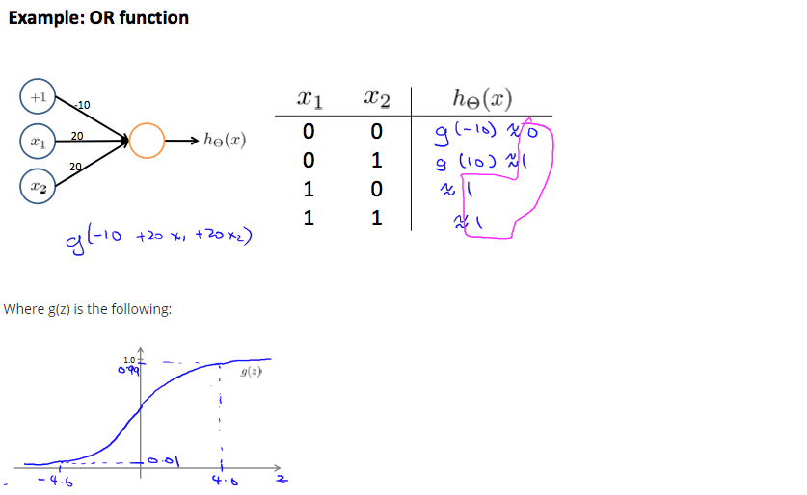

*Examples and Intuitions II*

* Remember XOR vs. OR and XNOR vs. NOR

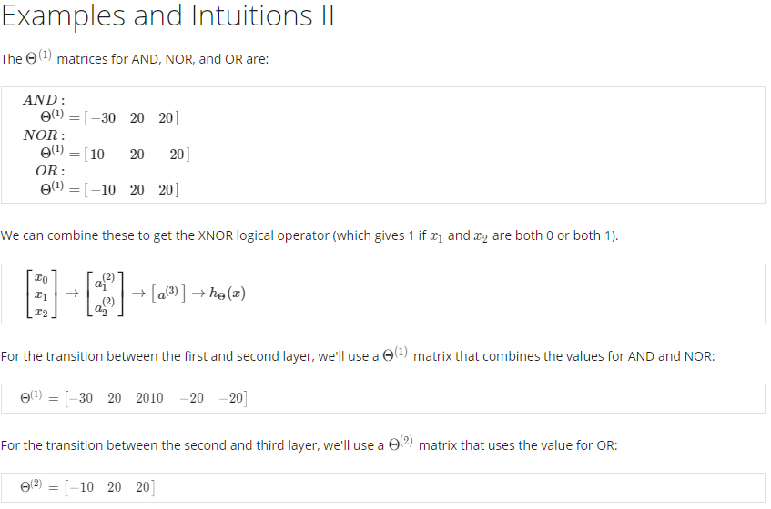

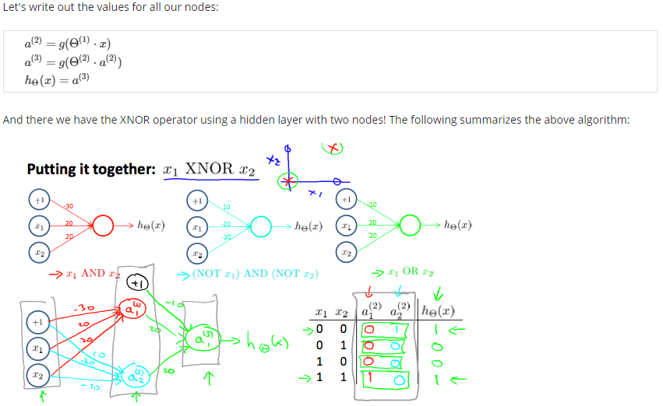

*Multiclass Classification*

* Multiple output units: One-vs.-all

